**Tab Slider**

Items Tab

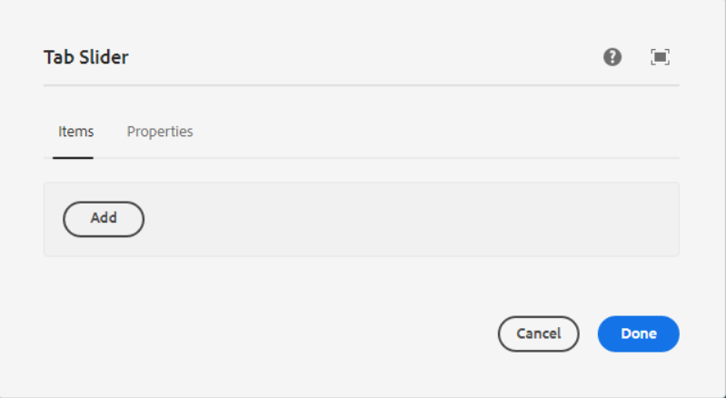

Inside Items Tab, we need to add a Tab slider Element Container component, also we have to provide the name to the tab slider element container. The name should be the same as tab title name

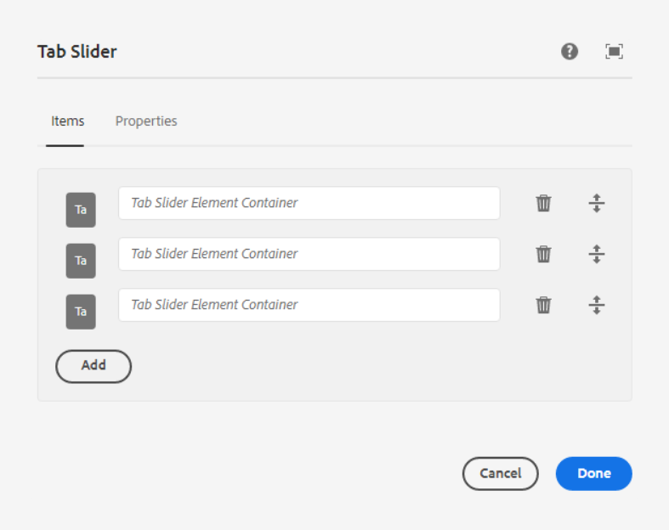

For E.g., Check below Screenshot

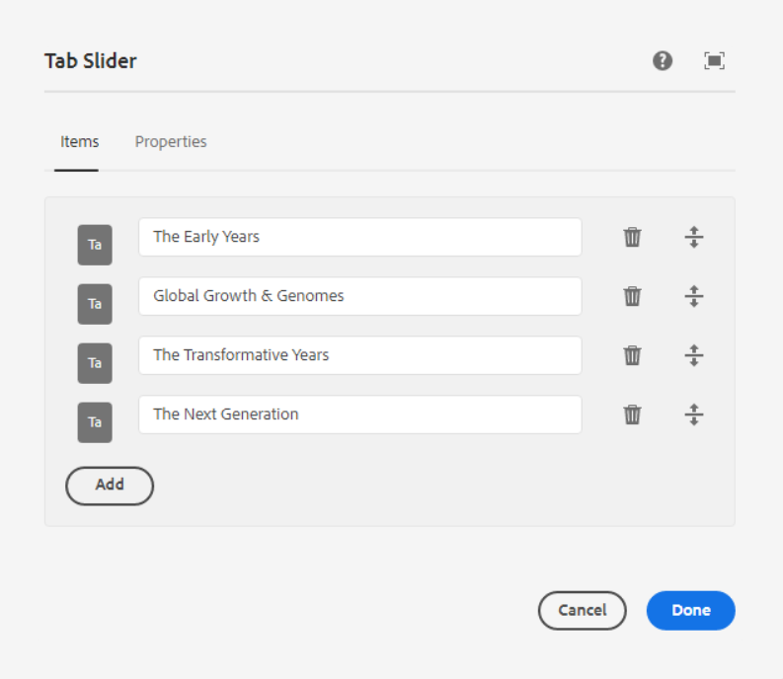



Properties Tab

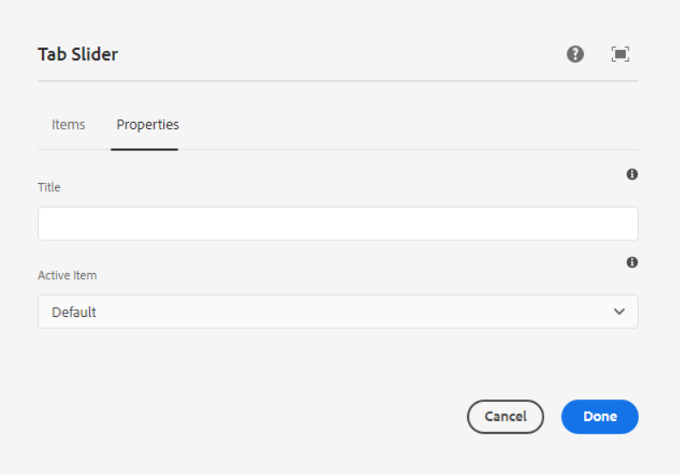

**Title –** Title of component

**Active Item** – The item that is active by default.

For E.g., Check the below screenshot to how active items are visible.

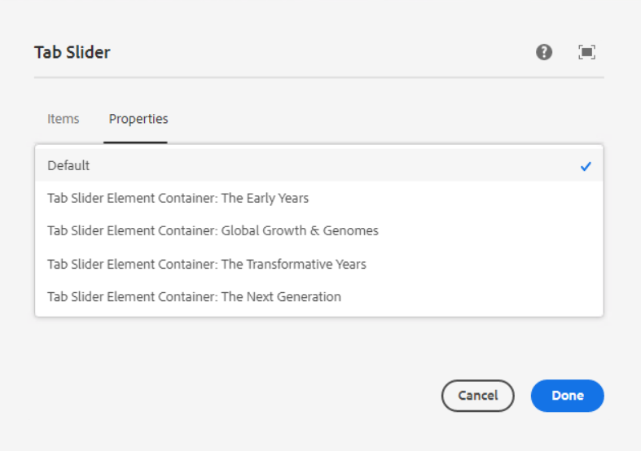

___________________________________________________________________Then we need to author the tab slider element Container, which is added inside the Tab slider.

**Tab Slider Element Container**

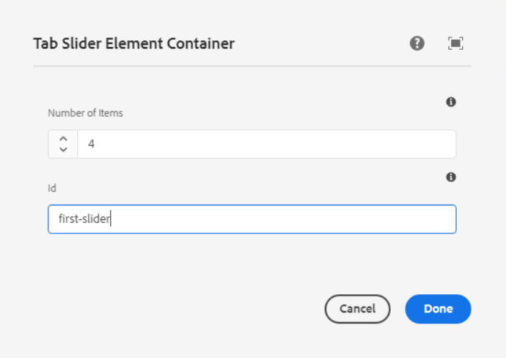

**Number of Items** - Number of Tab slider Element components to add in the container.

**ID** - Tab Slider Element Container ID and Tab Slider Element ID should be same within same container.

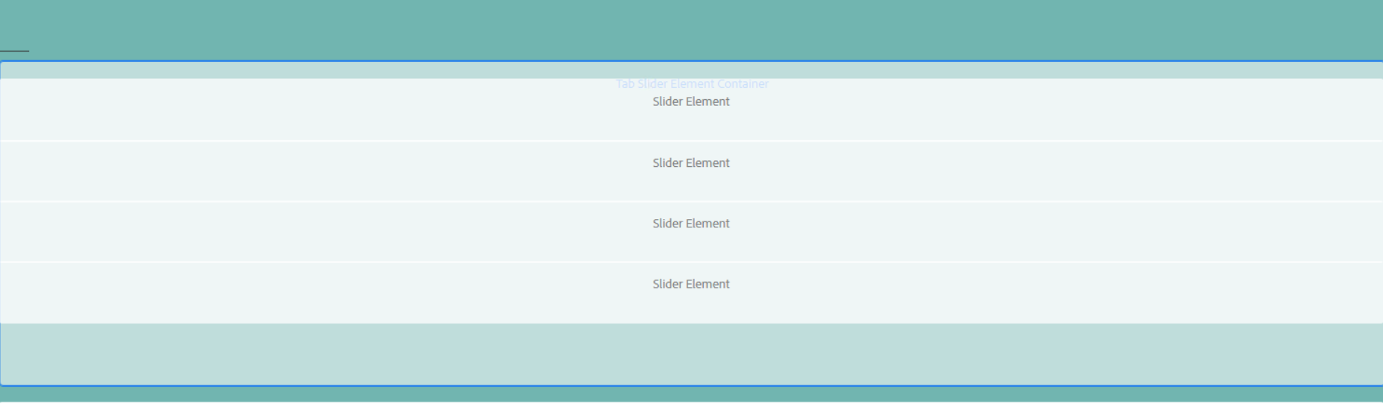

___________________________________________________________________ Then we need to author the tab slider element component, which is added inside the Tab slider element container.

**Tab Slider Element**

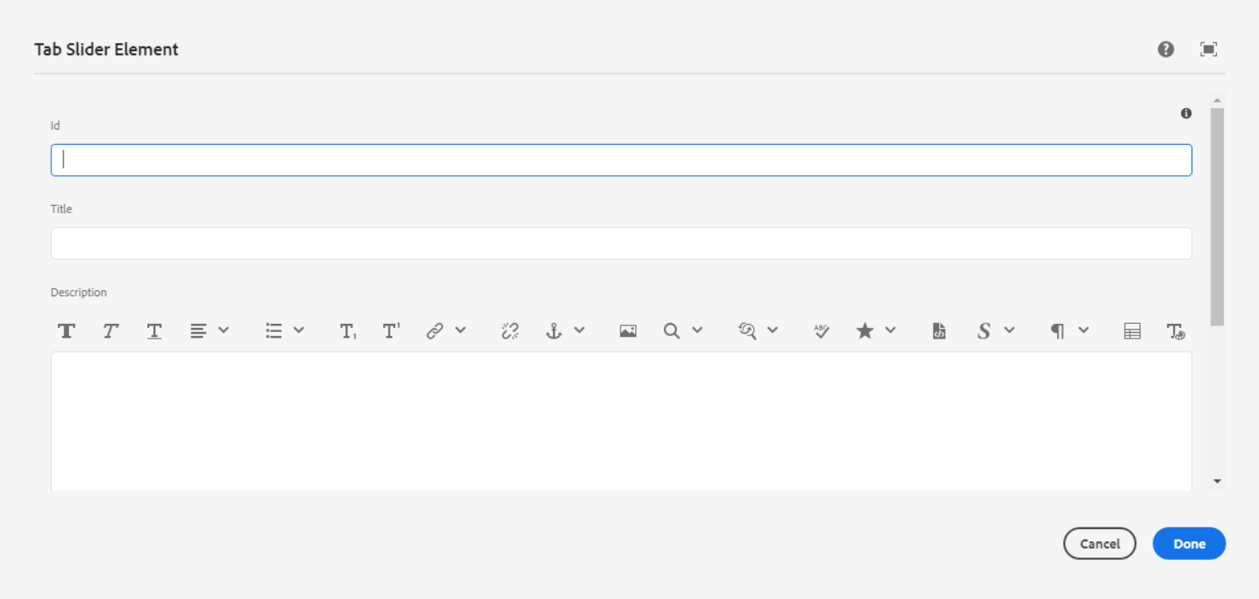

**ID** - Tab Slider Element Container ID and Tab Slider Element ID should be same within same container.

**Title** - This is for title

**Description** - This is for Description

**Image** - This is for Image

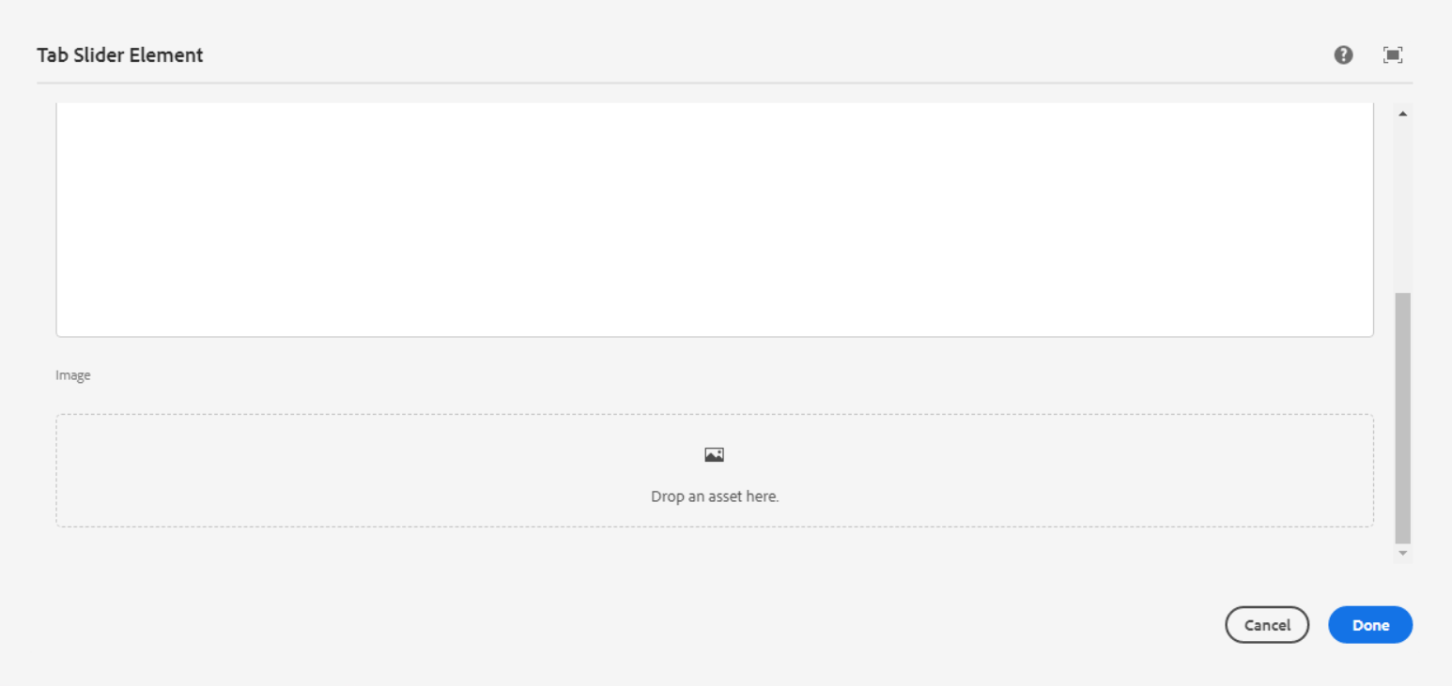

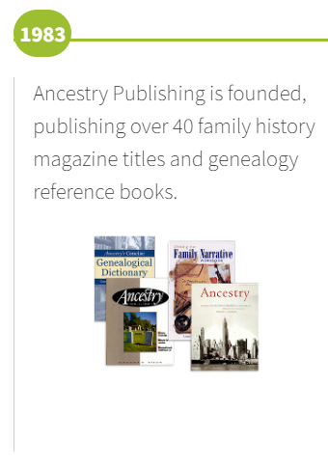

___________________________________________________________________

**Page Reference -** [**https://www.ancestry.com/corporate/about-ancestry/our-story**](https://www.ancestry.com/corporate/about-ancestry/our-story)

**AEM URL -** [**https://author-ancestry-dev2.adobecqms.net/content/ancestry-corp/us/en/about-ancestry/our-story.html?wcmmode=disabled**](https://author-ancestry-dev2.adobecqms.net/content/ancestry-corp/us/en/about-ancestry/our-story.html?wcmmode=disabled)

